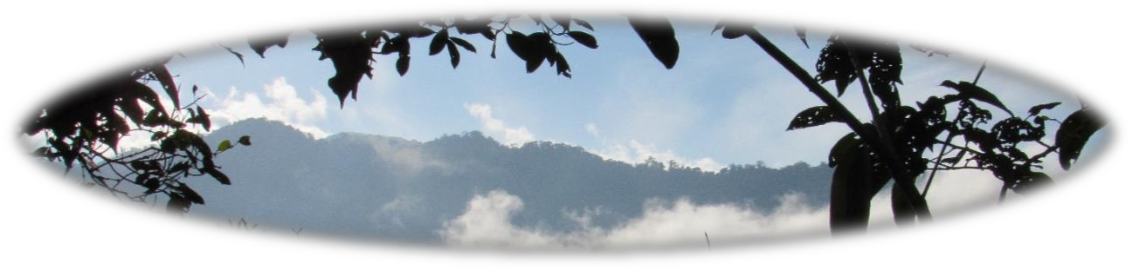
LEARNING AND FELLOWSHIP TOUR

Quito and the Ecuadorian Rainforest with
Delicia Bravo and Peter Wigginton, Jane and Jerrell Ross Richer
Mennonite Mission Network Ecuador Partnership workers

Proposed Dates: March 28-April 10, 2019 (14 days)

Have you ever wondered what it’s like to worship and serve God in the capital city with the second highest altitude in the world and then travel by boat into the Amazon basin? To meet followers of Christ who speak Spanish, Cofán, Kichwa and Shuar? To learn about urban ministry, including ministry with migrants and refugees, and also indigenous churches in the midst of the rainforest as God originally created it?

This is an opportunity to step into the Ecuador Partnership in which Central Plains Mennonite Conference, Iglesia Cristiana Menonita de Colombia and Mennonite Mission Network work together. (See https://www.mennonitemission.net/Impact/locations/Latin%20America/Ecuador )

We invite you to join Delicia and Peter and their two children – Aliyah and Ariana - in Quito, and Jane and Jerrell and their four children – Sierra, Naomi, Teresa and Jordan – on a pilgrimage to the Equator. Peter and Delicia serve as Ecuador Partnership coordinators in Quito and the Ross Richers walk alongside indigenous church leaders in a two-way mission that brings them to Ecuador for six months each year, living most of that time in the Cofan community of Zábalo.

We will visit church leaders and their families and encourage them as they seek ways to worship and serve within their unique cultural contexts. This is an opportunity to discover some surprising similarities between ministry challenges in the U.S. and Ecuador, and also between traditional indigenous worldviews and the Biblical worldview as we listen and share together. Sing and hear praises to our creator, redeemer and sustainer in new languages and deepen your understanding of the interconnectedness of God’s people.

You’ll be inspired by stories of Christians responding to the needs of other people around them, and also successfully conserving the land that is the foundation of the native cultures. We’ll have a chance to interact with Cofán in the village of Zábalo and learn how they are protecting their distinct customs and traditions while adapting to the changes brought by globalization – all of this while experiencing the marvel of God’s creation in an area known for its peak diversity in plants, birds, mammals and amphibians, one of the “wildest places on earth”.
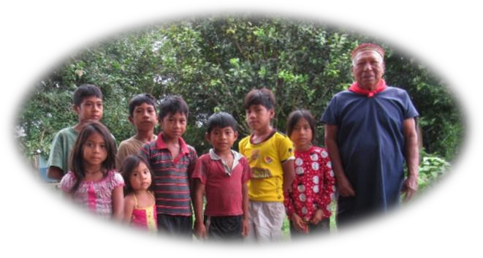
Join us on a journey of discovery in the Amazon rainforest as we take part in God’s reconciling work in the world -- reconciling ourselves to God, to others, to God’s creation, and to ourselves.

You will be physically and spiritually challenged
in up-close encounters, learning about issues you care deeply about – Christian faith, social justice, caring for God’s creation. Take some time away from your busy North American routine to listen to God and grow in your faith with a group of likeminded believers as we walk alongside our neighbors living along the Equator.
- Worship experiences with mestizo and indigenous Christians
- Interactions with urban and village leaders and children
- Opportunities to experience both urban ministry and the wild beauty of God’s creation
- Tours of historically- and culturally-important places with English speaking guides
- Interactions with local indigenous people (English translation as needed)
- Physically-demanding settings and spiritually-challenging experiences
- Daily devotional readings and time set aside for group reflection
Cost: $2,100 per-person – includes roundtrip airfare from Chicago to Quito and all meals, lodging, guides and transportation by bus and motorized canoe.

Accommodations: While in Zábalo, we will stay at a lodge with rustic accommodations, including single beds with mosquito nets, shared bathrooms with flush toilets, sinks and cold showers, and no internet, trading creature comforts for the opportunity to see new creatures – like Amazon River turtles and Woolly monkeys!

Vaccinations: Consult your doctor at least four weeks before departure to arrange for necessary vaccines and medicines. The U.S. Centers for Disease Control has specific recommendations at https://wwwnc.cdc.gov/travel/destinations/traveler/none/ecuador.

Registration To sign-up for the tour or request more information, please contact: Holly Blosser Yoder at yoderholly@gmail.com
Deposit and Payment We will collect $1,000 deposits until the tour reaches capacity. Make your deposit as soon as possible to guarantee a spot, and no later than February 1, 2019. Make your check payable to “Central Plains Mennonite Conference, PO Box 101, Freeman, SD, 57029. Indicate on the memo line of the check that this is for the “Fellowship and Learning Tour 2019. Final payment of $1,100 is due March 1, 2019.

