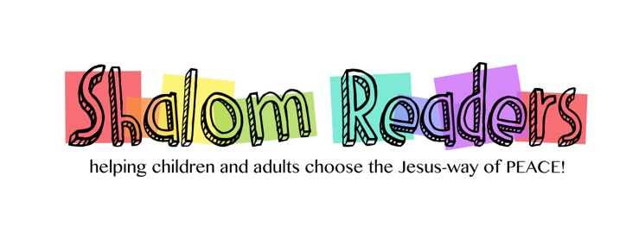

New Books for 2022

PreSchool-Grade 2
Be Kind-by Pat Zietlow Miller, Illust. by Jen Hill, Roaring Brook Press, 2018. When Tanisha spills grape juice all over herself it causes a classmate to begin thinking about how to show kindness in all sorts of situations.

Little Blue Truck and Little Blue Truck Leads the Way by Alice Schertle, Illust. by Jill McElmurry, Harcourt Children’s Books, 2008, 2009. Old favorites that show in rhyming text how a helping hand from a friend or taking turns can get us out of sticky situations.

Thank You, Omu!-Oge Mora, Little, Brown Books for Young Readers, 2018. Omu, (Grandma) gives away bowls of soup until there is none left for her own supper, but the community returns to share with her.

Watercress by Andrea Wang, Illust. by Jason Chin, Neal Porter Books, 2021. Based on the author’s own memories of being the child of Chinese immigrant parents she recalls her resistance to stopping the family car to pick watercress in a roadside ditch believing that “free is bad” until her mother shares a story from her past.

3rd-5th Grade
Act-Kayla Miller, HMH Books for Young Readers, 2020. In this graphic novel, when Olive finds out that a school policy is keeping some kids from going on the class field trip, she decides to act, and runs for office in the student council. Do students have the power to make a difference? Book includes a list of groups that brought about change by peaceful protests throughout history.

Rez Dogs-Joseph Bruchac, Dial Books, 2021. In this novel in verse, Malian was visiting her grandparents on the Penacook Reservation when shelter in place orders are given for COVID-19. So she makes the best of the extended amount of time with her grandparents while her parents are back home in Boston, doing school online, listening to the stories of the old ways, enjoying traditional foods, and making friends with a protector dog.

Restart-Gordon Korman, Scholastic, 2018. After Chase falls off a roof and is left with amnesia, he realizes that he had been the biggest bully in school. Now he hopes to reinvent himself but it’s hard when most of his acquaintances are afraid of him.

6th-8th Grade
Breakout-Kate Messner, Bloomsbury Childrens, 2018. Through letters, poems, text messages, news stories and comics, three middle schoolers discuss how they and the people in their town change when two inmates break out of the nearby maximum security prison.

The Only Road-Alexandra Diaz, Simon & Schuster, 2016. Inspired by true events, this is the story of a boy who feels that leaving home and everything he knows is his only chance for not only a better life, but to live and the treacherous journey he takes to get there.

Linked-Gordon Korman, Scholastic, 2021. When a swastika shows up on the wall of the middle school students are shocked and wonder who put it there. Media attention and finger-pointing follow as more swastikas appear and crimes of the past and present are probed for answers. As this tears the town apart, one group of students tries to bring people together.

