Report, Jardines del Inca and Vida Juvenil
Alyssa Rodriguez
New church plant
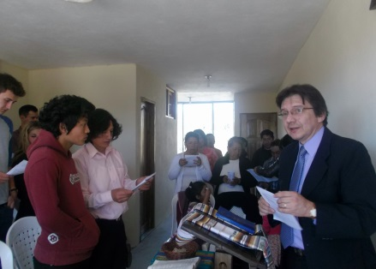
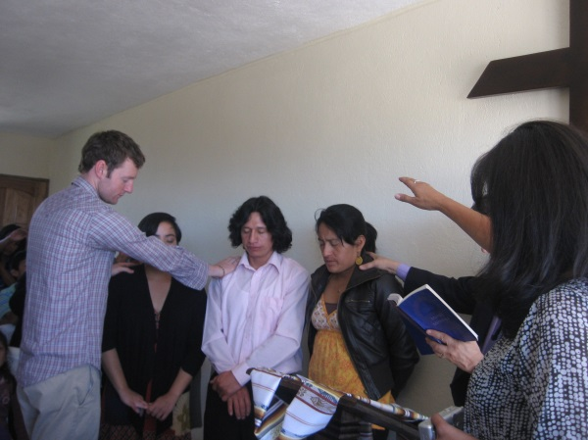
The Jardines del Inca congregation began on Sunday, July 28, 2013. Nearly thirty-five people attended the inaugural worship service, including a Youth Venture (Mennonite Mission Network program) group of 7 youth and young adults from the United States. Some of the Youth Venture members had visited/been hosted in the Jardines del Inca barrio and helped to paint the new church’s space a week prior. Thank you to the youth of Christ Community Church (Des Moines, IA) who offered their support! Other attendees consisted of some members from the Quito Mennonite church who offered their support and the remaining majority was the immediate and extended family of Quito Mennonite Church secretary, Alba Silva; Pastors Cesar Moya and Patricia Urueña and Alyssa Rodriguez. Alba Silva, Oswaldo Moina and Alyssa Rodriguez were installed as the new church’s council, with full approval from those attending. Together the three will take on responsibilities of church maintenance, finances and pastoral roles (as in planning worship services, visiting current church members and inviting prospective ones). The goal is for the offering and tithes of the members to be sufficient to pay the monthly rent, provide coffee/cookies or a light breakfast to attendees after the service, purchase cleaning supplies, etc. Your prayers are welcomed for these new duties taken on by Oswaldo, Alba and Alyssa and for the possibility that other Jardines del Inca members be encouraged to participate in the work of the church as well. With almost a month passed since its inauguration, number of attendees ranges from 15-30 each week. On August 18, two of the youth of Jardines Del Inca, Bryan Moina and Lizeth Silva were baptized; marking the first baptisms of the Jardines del Inca’s history! Please also pray for the new church as it is located in a barrio that carries a heavily Catholic tradition which adds the challenge of working ecumenically with neighborhood residents and believers of different faith traditions.
Family Group
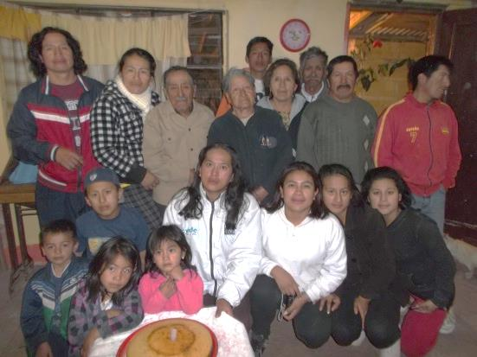
Every other week, the Jardines del Inca family group meets to participate in Bible study and a time of sharing and prayer while being served a small snack/beverage by the host. Alba, Oswaldo and Alyssa have taken on the sharing of hosting duties. With the acquisition of the new church space, the group has decided to have that site be the permanent meeting space for family group meetings so that the group is more visible/accessible to other individuals in the neighborhood who might be interested in attending. Pray for Mary – she only often shares within the family group setting, where she feels safe/comfortable in expressing her feelings. When she does share, she notes her jealous tendencies, her struggle to be welcoming to certain people (i.e. Colombians) and her difficulty in forgiving. Give thanks for her openness in this setting and pray for restoration where it is needed so Mary can forgive, welcome fully and truly know/be God’s love. On any given week, 18 members attend (everyone consisting of Alba’s immediate/extended family members except for Alyssa and the Pastor). The group, in following with Quito Mennonite Church’s practice of having each different family group (divided up by members’ residence) takes on Worship leading duties every few weeks and will continue to do so even with the introduction of the new congregation. It is not uncommon, when the Jardines del Inca family group leads worship in the Quito Mennonite Church to see the youth like Bryan, Josue, Brigithe, Lizeth and Saul helping out.
1Celebrating Great Grandpa Julio's Birthday.
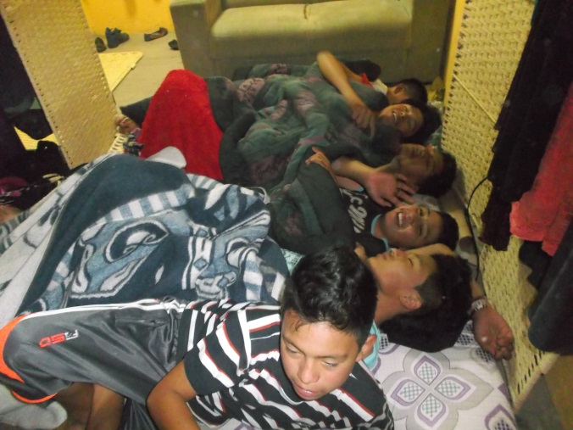
Youth of Jardines del Inca, Vida Juvenil
Within the Jardines del Inca membership (primarily the Silva family), there are numerous youth who have the potential to grow in their relationship with God. The above listed youth are regular attendees of the congregation, while other cousins in the family participate occasionally in other church-related activities (soccer games, sleepovers, Peace Education workshops, Vida Juvenil, etc.) As the new church takes form, these youth will be kept in mind so the work in building their faith is not lost out.
2Sleepover at Alyssa's house!
Vida Juvenil
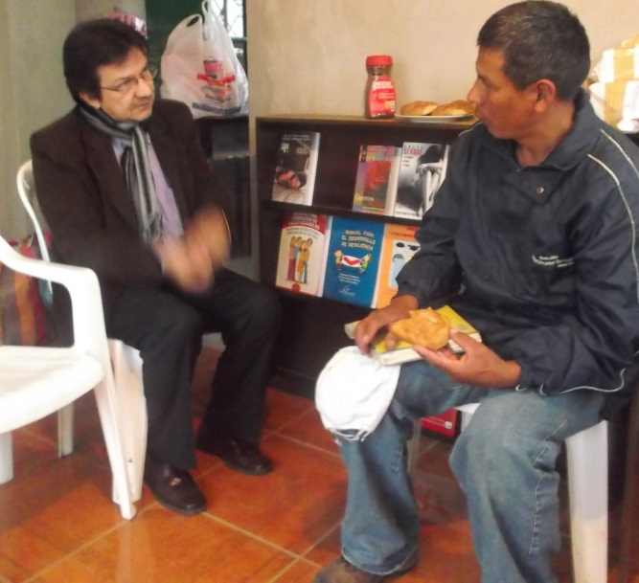
Vida Juvenil is one of the newest projects of the Quito Mennonite Church and is based in the Jardines del Inca neighborhood. The project aims to provide educational workshops for youth and parents in the neighborhood to lower the occurrence of early pregnancies (for youth between ages of 10-14) in girls living there. The project’s team consists of Alyssa; the coordinator, Bryan Moya, Brigithe Silva, Lizeth Silva, the pastors, Karen Sanchez and Karen Guapaz. The Vida Juvenil space will also serve as a place for youth to hang out, seek counsel and learn more about sexual and reproductive education; including a common interest, how to have healthy relationships with members of the opposite sex. To initiate the project, Pastor Moya and Alyssa met with the neighborhood association various times and then with the entire neighborhood to make residents aware of the project and its intentions. Additionally, the Vida Juvenil group, along with other members of the church conducted surveys within the neighborhood to assess youth/parents’ knowledge about sexual and reproductive education; to assess how many young pregnancies have already occurred in the neighborhood and to find out youth’s schedules/interests so that the monthly workshops can be tailored to their needs. Of the 36 households that were surveyed, there had been 3 pregnancies – one of a girl who was 13 years old. The majority of families responded with interest in participating in the project and many families are anxiously awaiting the first workshop that will be this Saturday, August 24. Pray that the team of mostly youth can feel motivated to participate in the project as their young perspective and insights are invaluable. Pray that Alyssa and the project can continue building a trustworthy presence in the neighborhood and that the project’s affiliation with the Mennonite church not be a barrier for youth to get involved in the project.
3Pastor Moya and the neighborhood President, German Vargas.

